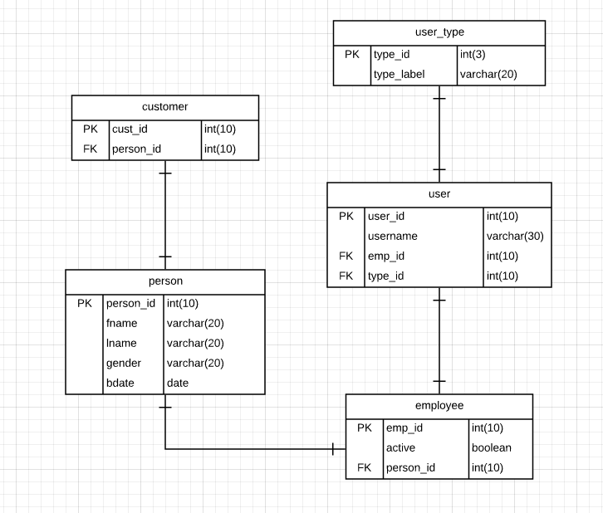

Tables

1. Person – contains the general information of a personal entity. Business customers not yet considered into this table
2. Customer – table primarily used for customers. Uses Person table as a container for further information about the customer
3. Customer – table primarily used for employees. Uses Person table as a container for further information about the employee
4. User – contains all information about the users of the system. Limited to the admin and the employee only
5. User Type – table used for privilege constraints on users